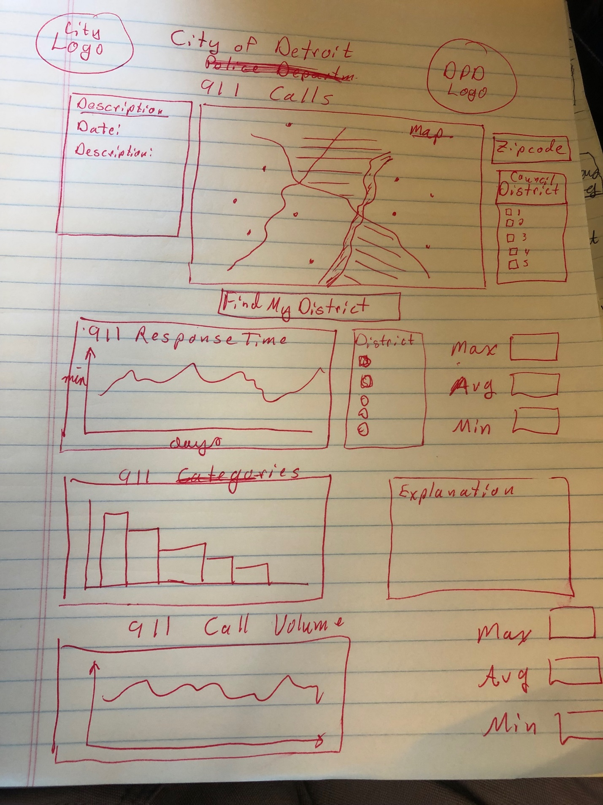

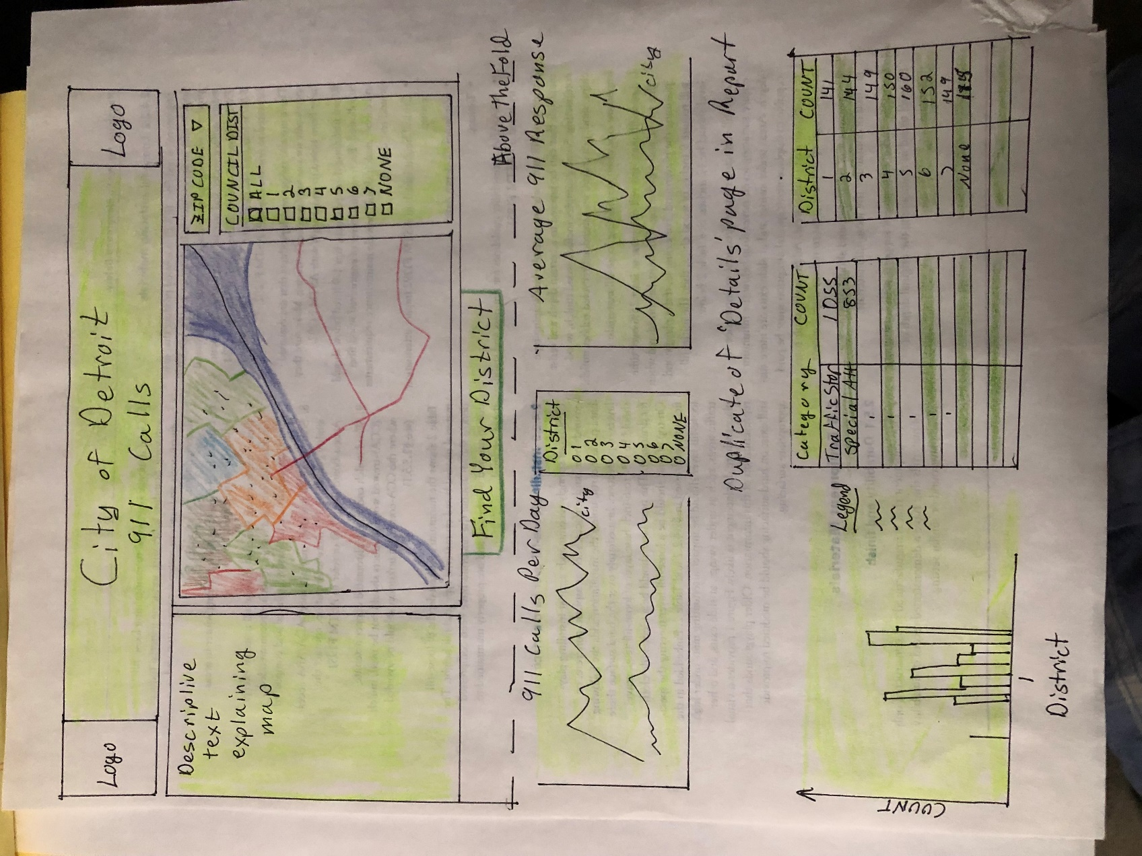

Feedback to have a single district slicer instead of one for the map and one for the graphs below was not used after contemplation. The map has three slicers for zipcode, council district, and the week. Only the Council District would be applicable to the graphs below. Additionally, the map and the graphs are too large to appear on the screen at the same time. Having dedicated slicers for each section will prevent the user from having to scroll with every district change.

